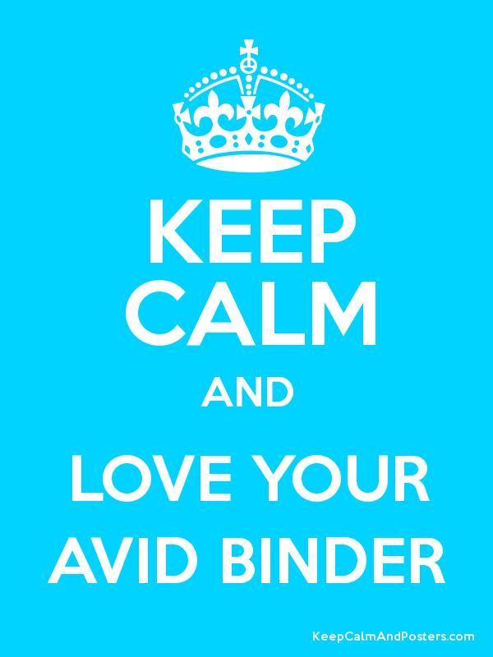
The Night(mare)
Before Notebooks

Notebooks are a large part of a student’s grade in AVID and we want them to come ready for their Binder Checks. Please have your student give you a tour of their notebook and then place a check-mark in the appropriate boxes below.

Yes No
1) Zangle Grade-check: Current grade for all 5 academic classes (not PE), included on Bider Check form with parent signature.

2) Notes: All notes for the last two weeks are complete with proper format and heading Title, Essential Question or Learning Goal written, and date in ink, left-side questions, a summary, and evidence of revision of notes. Learning Logs can used for partial credit (4/6) in the place of notes when no note-taking opportunities existed in a class.

3) Organization: All papers in the notebook are in the binder rings, none are stuck into the pockets unless they can explain a legitimate reason for them being there. Each section of Binder is organized with notes in order, handouts in order, and returned work in order by date.

4) Materials: Student has at least two pencils, two pens, a pencil pouch/box, and extra blank paper in their notebook or backpack.

5) Overall, the notebook is neat and in good condition with
no papers falling out.

Parent/Guardian Section
My student has given me a tour of their notebook. I have checked it for the 5 things above.

Parent Signature: ______________________________________________

Student Name: ________________________________________________

